Supplementary material

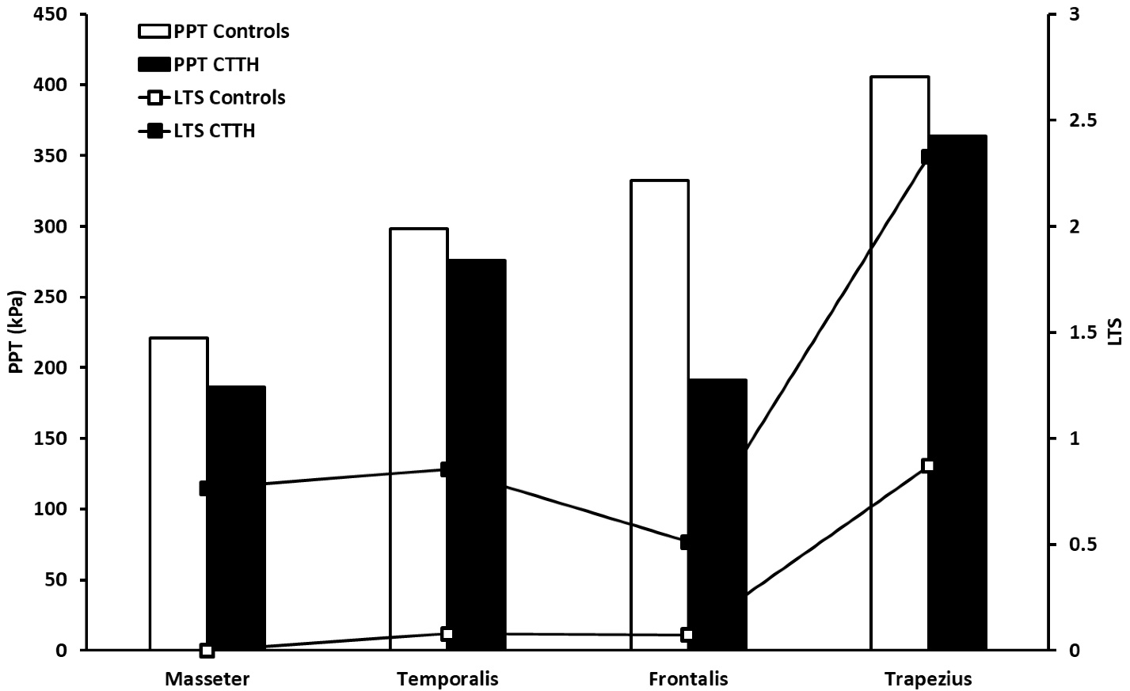

**Supplementary Fig. 1. Pressure pain thresholds (PPT) and Local Tenderness Scores (LTS) in chronic tension type headache (CTTH) patients and healthy controls.** The LTS data were retrieved from Bendtsen *et al.* [55] whereas the PPT data were taken from Andersen *et al.* [135] and Castien *et al.* [98]. The paradox is that the masseter muscle has the lowest PPT values (most sensitive) but the lowest LTS (least sensitive) in comparison to the trapezius muscle.